**GRADLE EXERCISE SHRIYA GARG**

Q1

Add a gradle dependency and its related repository url.

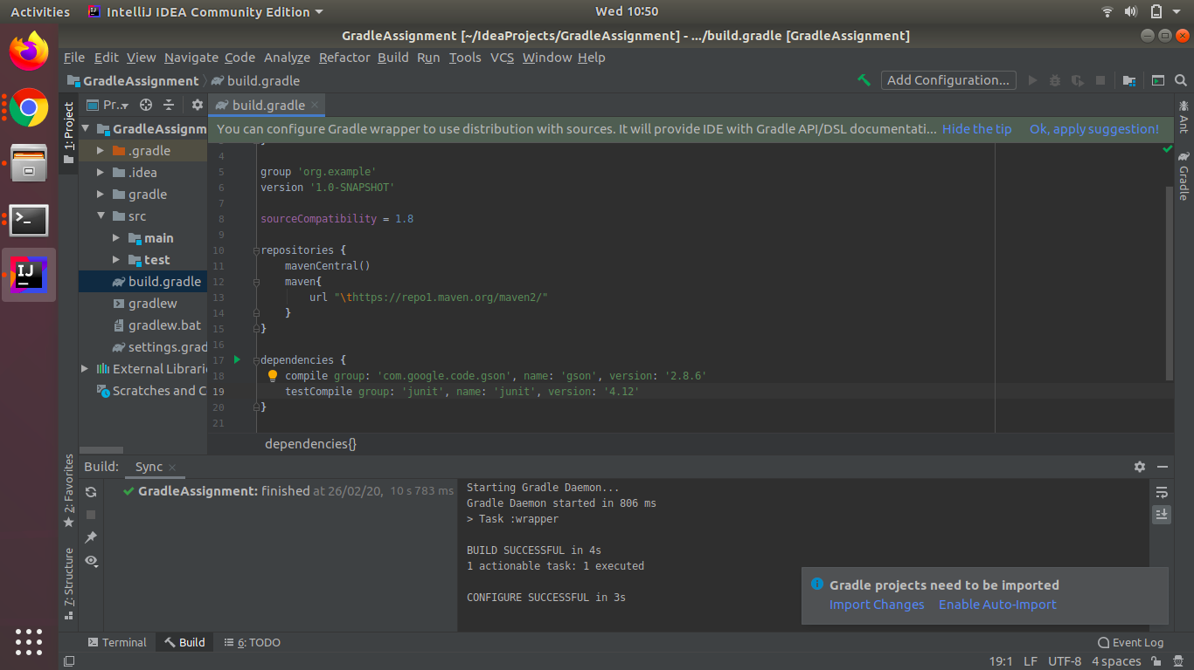

Q2

Using java plugin, make changes in the manifest to make the jar executable. Using java -jar JAR_NAME, the output should be printed as "Hello World"

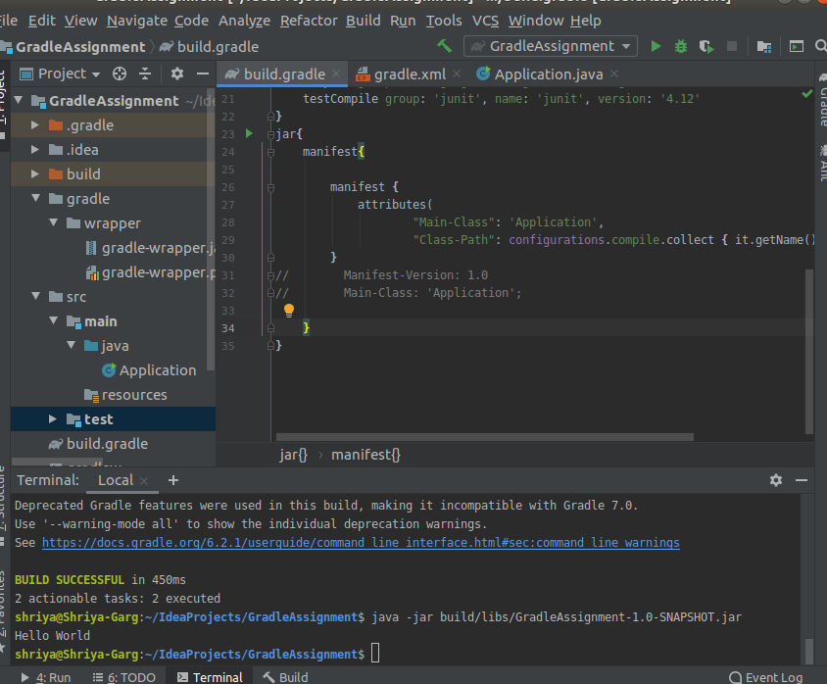

Q3.

Differentiate between the different dependency scopes: compile, runtime, testCompile, testRuntime using different dependencies being defined in your build.gradle.

* Compile − The dependencies required to compile the production source of the project.
* Runtime − The dependencies required by the production classes at runtime. By default, also includes the compile time dependencies.
* Test Compile − The dependencies required to compile the test source of the project. By default, it includes compiled production classes and the compile time dependencies.
* Test Runtime − The dependencies required to run the tests. By default, it includes runtime and test compile dependencies.

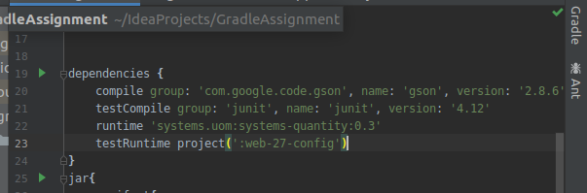

Q4

Create a custom plugin which contains a custom task which prints the current date-time. Using that plugin in your project, execute that task after the jar task executes.

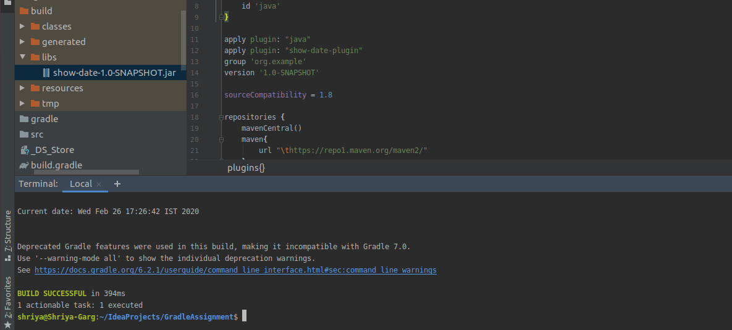

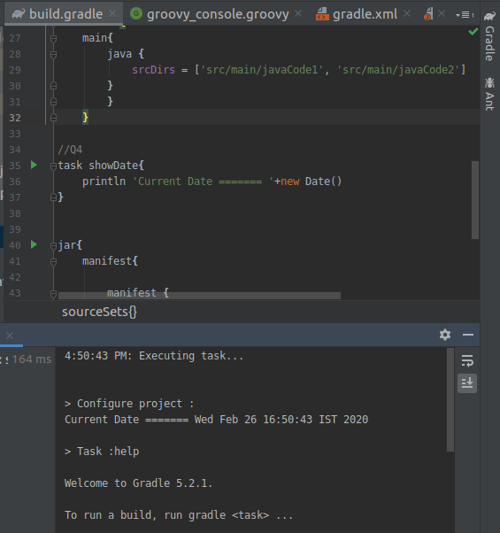

Q5

Instead of using default source set, use src/main/javaCode1, src/main/javaCode2 to be taken as code source. Make sure that the JAR created contains files from both the directories and not from src/main/java.

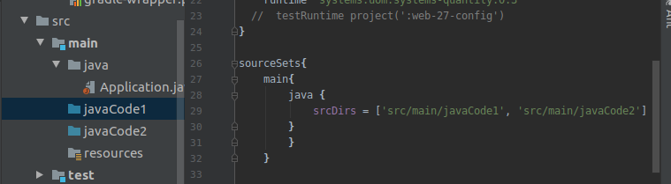

Q6

Override the Gradle Wrapper task to install a different version of gradle. Make sure that the task written in Q4 also executes with it.

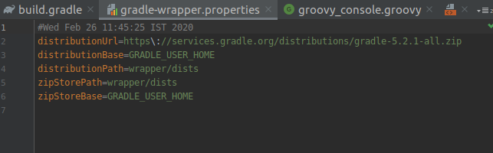

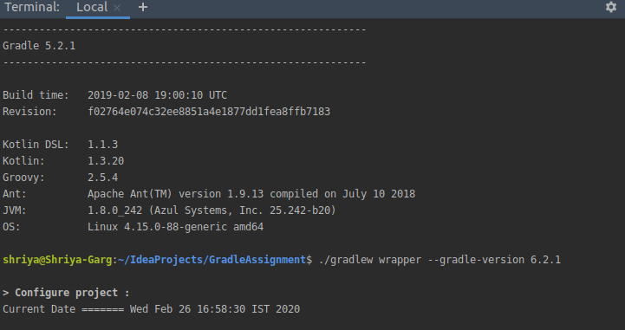

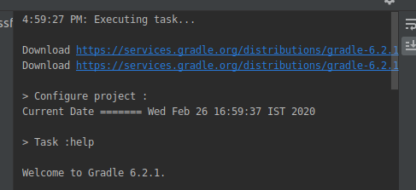

Q7

Run the gradle profile command and attach the resulting files.

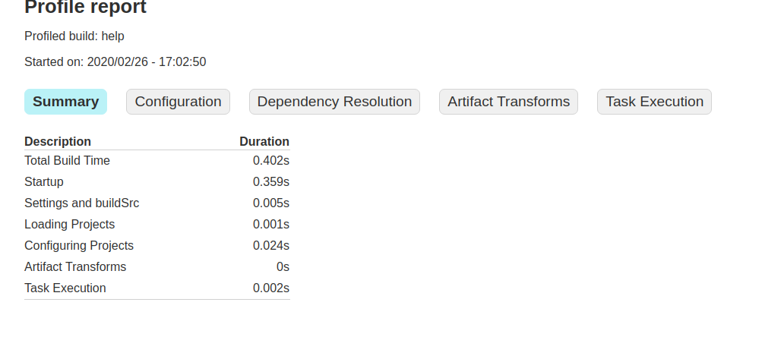

<!DOCTYPE html>

<html>

<head>

<meta http-equiv="Content-Type" content="text/html; charset=utf-8"/>

<meta http-equiv="x-ua-compatible" content="IE=edge"/>

<title>Profile report</title>

<link href="css/base-style.css" rel="stylesheet" type="text/css"/>

<link href="css/style.css" rel="stylesheet" type="text/css"/>

<script src="js/report.js" type="text/javascript"></script>

</head>

<body>

<div id="content">

<h1>Profile report</h1>

<div id="header">

<p>Profiled build: help </p>

<p>Started on: 2020/02/26 - 17:02:50</p>

</div>

<div id="tabs">

<ul class="tabLinks">

<li>

<a href="#tab0">Summary</a>

</li>

<li>

<a href="#tab1">Configuration</a>

</li>

<li>

<a href="#tab2">Dependency Resolution</a>

</li>

<li>

<a href="#tab3">Artifact Transforms</a>

</li>

<li>

<a href="#tab4">Task Execution</a>

</li>

</ul>

<div class="tab" id="tab0">

<h2>Summary</h2>

<table>

<thead>

<tr>

<th>Description</th>

<th class="numeric">Duration</th>

</tr>

</thead>

<tr>

<td>Total Build Time</td>

<td class="numeric">0.402s</td>

</tr>

<tr>

<td>Startup</td>

<td class="numeric">0.359s</td>

</tr>

<tr>

<td>Settings and buildSrc</td>

<td class="numeric">0.005s</td>

</tr>

<tr>

<td>Loading Projects</td>

<td class="numeric">0.001s</td>

</tr>

<tr>

<td>Configuring Projects</td>

<td class="numeric">0.024s</td>

</tr>

<tr>

<td>Artifact Transforms</td>

<td class="numeric">0s</td>

</tr>

<tr>

<td>Task Execution</td>

<td class="numeric">0.002s</td>

</tr>

</table>

</div>

<div class="tab" id="tab1">

<h2>Configuration</h2>

<table>

<thead>

<tr>

<th>Project</th>

<th class="numeric">Duration</th>

</tr>

</thead>

<tr>

<td>All projects</td>

<td class="numeric">0.024s</td>

</tr>

<tr>

<td>:</td>

<td class="numeric">0.024s</td>

</tr>

</table>

</div>

<div class="tab" id="tab2">

<h2>Dependency Resolution</h2>

<table>

<thead>

<tr>

<th>Dependencies</th>

<th class="numeric">Duration</th>

</tr>

</thead>

<tr>

<td>All dependencies</td>

<td class="numeric">0.007s</td>

</tr>

<tr>

<td>:compile</td>

<td class="numeric">0.007s</td>

</tr>

</table>

</div>

<div class="tab" id="tab3">

<h2>Artifact Transforms</h2>

<table>

<thead>

<tr>

<th>Transform</th>

<th class="numeric">Duration</th>

</tr>

</thead>

<tr>

<td>All transforms</td>

<td class="numeric">0s</td>

</tr>

</table>

</div>

<div class="tab" id="tab4">

<h2>Task Execution</h2>

<table>

<thead>

<tr>

<th>Task</th>

<th class="numeric">Duration</th>

<th>Result</th>

</tr>

</thead>

<tr>

<td>:</td>

<td class="numeric">0.002s</td>

<td>(total)</td>

</tr>

<tr>

<td class="indentPath">:help</td>

<td class="numeric">0.002s</td>

<td></td>

</tr>

</table>

</div>

</div>

<div id="footer">

<p>

<div>

<label class="hidden" id="label-for-line-wrapping-toggle" for="line-wrapping-toggle">Wrap lines

<input id="line-wrapping-toggle" type="checkbox" autocomplete="off"/>

</label>

</div>Generated by

<a href="http://www.gradle.org">Gradle 6.2.1</a> at 26 Feb, 2020 5:02:50 PM</p>

</div>

</div>

</body>

</html>